**Innovative Monitoring System for TeleICU Patient Using Video Processing and Deep Learning.**

# Objective:

* Intension behind creating this project is to do some advancement with existing TeleICU System.
* To reduce the monitoring task overload,we need some kind of system which can do basic as well as advance work of monitoring by itself.
* TeleICU System is a System in which Intensivist monitors the ICU patients from remote location. It is made for overcome shortage of Intensivist & ICU Nurse.
* We are Proposing the “Innovative Monitoring System for TeleICU Patients”which is capable of monitoring the critical care patient &make collaboration with person at control center of TeleICU.
* Intension behind developing such system is to avoid human errors and fulfill all type of requests by critical care patients with small number of medical staff.

## Challenges:

* Data Collection and Pre-Processing of data for supervised learning approach.
* After Creation of labeled data ,the challenge was detection of patient from the frame. Detection is difficult because so many types of person available in the frame.
* For motion detection in scene the challenge is so many moving objects available in the frame e.g.,ECG machine.the motion done these machines is also captured by algorithm so,only patient movements detection is difficult.
* Coordination between the Existing TeleICU System and Our System
* High Accuracy and Timing of Prediction needs more focus.

## DataSet:

## 1.Video Data:

* **Live Feeds**: Recordings or live feeds from cameras placed in ICU rooms capturing patient movements, vital sign monitors, and medical equipment.
* **Annotations**: Manual or automated labeling of video segments to indicate activities (e.g., patient turning, vital sign changes, interactions with medical staff).

## 2. Vital Signs and Patient Data:

* **Continuous Monitoring**: Data streams from ICU monitors (e.g., heart rate, blood pressure, oxygen saturation) collected at regular intervals.
* **Electronic Health Records (EHR)**: Patient history, medications, diagnoses, and treatment plans available for context.

## 3. Annotations and Labels:

* **Activity Recognition**: Labels indicating different patient activities (e.g., lying down, sitting up, coughing, talking).
* **Health State**: Labels indicating critical events (e.g., respiratory distress, cardiac arrest) for training deep learning models to recognize emergencies.

## 4. Environmental Data:

* **Room Conditions**: Temperature, humidity, ambient noise levels, which might affect patient comfort and health.

## 5. Model Training and Testing:

* **Training Set**: A large portion of labeled data for training deep learning models to recognize patient activities, detect anomalies, and predict health outcomes.
* **Validation Set**: Data used to fine-tune models during development.
* **Testing Set**: Separate data used to evaluate model performance objectively before deployment.

## 6. Privacy and Ethical Considerations:

* **Data Anonymization**: Ensure patient privacy by anonymizing personal identifiers in video and health data.
* **Ethical Approval**: Obtain necessary approvals from ethics committees or institutional review boards.

## 7. Data Sources:

* **Hospital Networks**: Partner with hospitals to access real-world ICU data.
* **Simulated Data**: Use simulations to generate synthetic data for scenarios that are rare or difficult to capture in real-time.

## 8.Data Collection Tools:

* **Video Processing Tools**: Software for annotating video data and extracting features.
* **Data Integration Platforms**: Tools to integrate and preprocess data from various sources for model training.

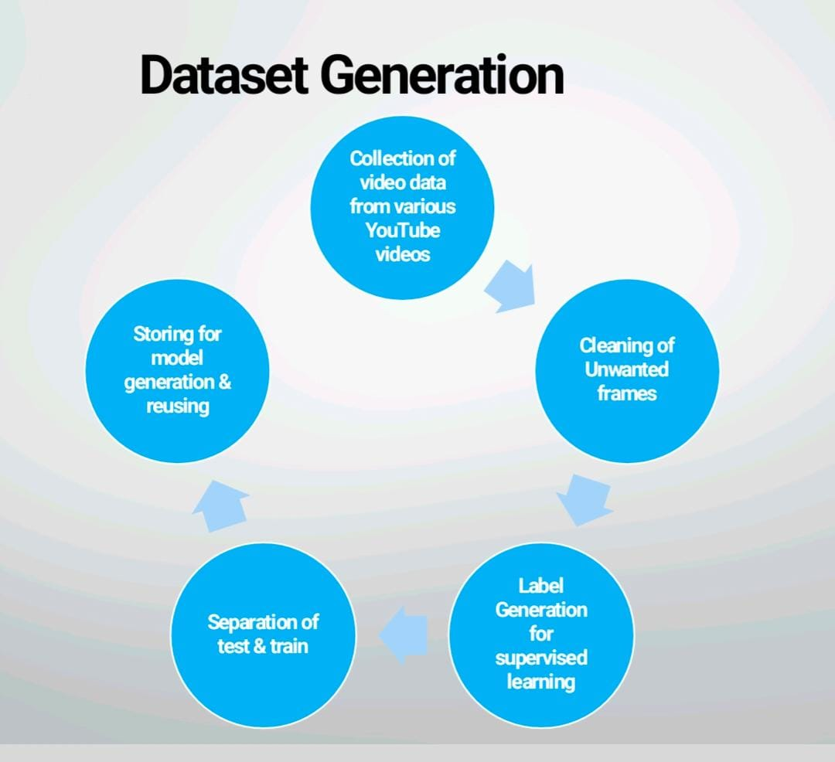

## Flowchart

This flowchart illustrates the key steps in remote patient monitoring for an ICU patient using a telehealth system:

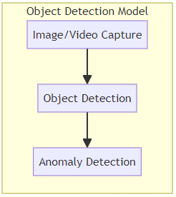 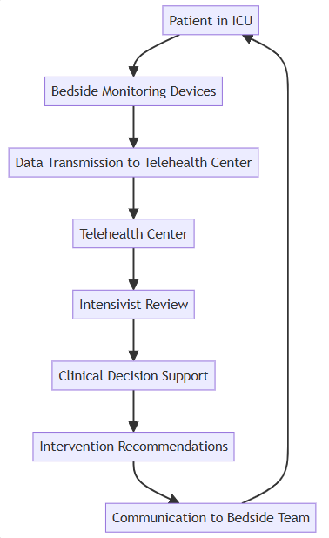

1. The data transmitted from the bedside devices includes image and video data, in addition to the patient monitoring data.
2. At the telehealth center, an object detection model is used to analyze the image and video data.
3. The object detection model first captures the images/videos, then performs object detection to identify relevant objects or anomalies.
4. The output from the object detection model is then used by the intensivist during the review process, along with the patient monitoring data.
5. The patient is in the ICU, with bedside monitoring devices collecting real-time data.
6. The patient data is transmitted from the bedside devices to the telehealth center.
7. At the telehealth center, an intensivist reviews the patient data.
8. Clinical decision support systems analyze the data and provide intervention recommendations.
9. The recommendations are communicated back to the bedside care team.
10. The bedside team implements the recommended interventions, which are then monitored by the telehealth system, completing the feedback loop.

This flowchart provides a high-level overview of the key components and workflow involved in remote ICU patient monitoring using a telehealth system.

## TeleICU System Detection :

## 

## 

## 

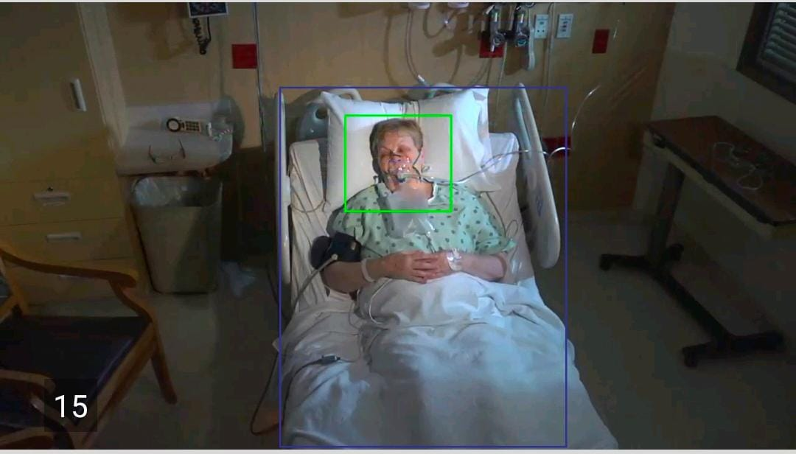

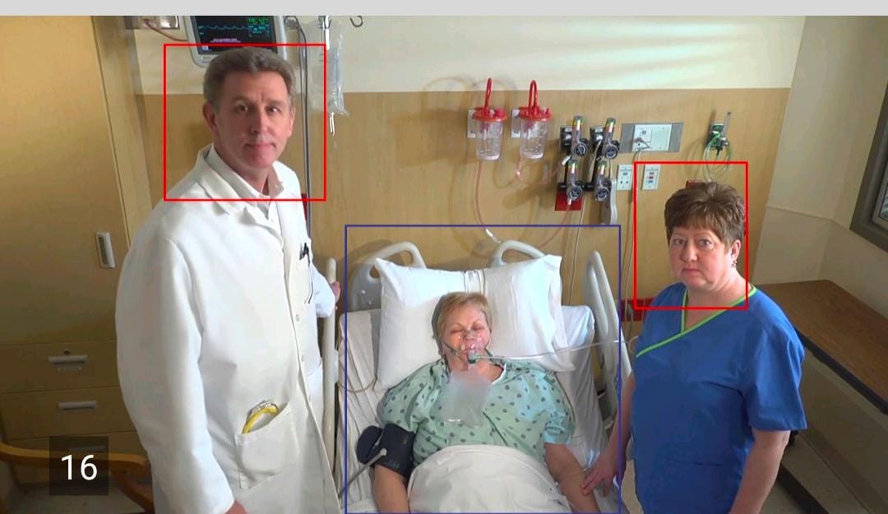

## Benefits of TeleICU Monitoring Systems:

1. Enhanced patient safety and quality of care
2. Improved access to critical care expertise in underserved or rural areas
3. Increased efficiency and resource optimization in ICU operations
4. Reduced healthcare costs through better patient outcomes and reduced complications
5. Continuous monitoring and early intervention to prevent adverse events
6. Collaboration and communication between remote and on-site care teams

Overall, the TeleICU monitoring system represents a transformative approach to delivering critical care, leveraging technology to improve patient outcomes, optimize resource utilization, and enhance the overall quality of intensive care services.

Participant : Monika P V

Guide: Vidya H A